Frost Indication Telltale – CGEA1.3

Functional Description

The purpose of the Frost Indication Telltale is to inform the driver when external air temperature falls below 4 ºC or 39 ºF.

The FrostWarn_D_Stat output signal is used by the FoE Micro Hybrid team. Stop-Start engine can be calibrated to be inhibited at cold temperatures.

The Frost_Indication_Telltale correlates the Outside_Air_Temp_Stat and Outside_Air_Temp_Stat_UB Signals from the HVAC or the FCIM (which contains HVAC) (gatewayed through SDLC) and the Operational_Mode to illuminate or extinguish the telltale. The Fixed Telltale is illuminated during Bulb Proveout.

The Frost Indication Telltale shall provide an iconic representation that will illuminate to inform the driver of an extremely cold (icy) driving conditions.

Interfaces

Interface Context Diagram (I/O Block Diagram)
Figure 1 Frost Indication Telltale Interface Context Diagram
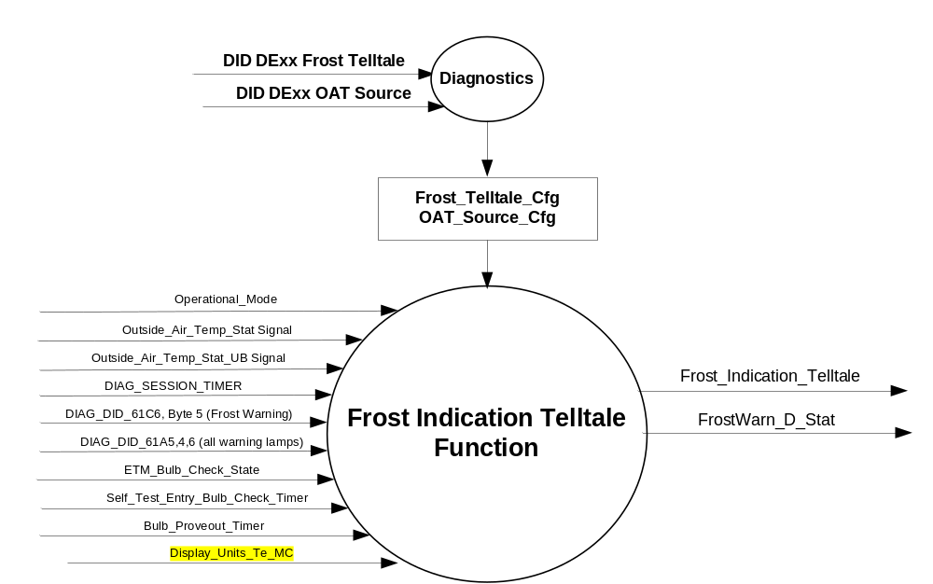

Inputs

      - INTERNAL:
            - DIAG_SESSION_TIMER
            - Operational_Mode
            - Bulb_Proveout_Timer
            - DIAG_DID_61C6, Byte 5 (Frost Warning)
            - DIAG_DID_61A5,4,6 (all warning lamps)
            - Display_Units_Te_MC (current Celsius/Fahrenheit setting from Display Unit Selection Control Function - CGEA1.3 STSS)
            - ETM_Bulb_Check_State
            - Self_Test_Entry_Bulb_Check_Timer
      - MUX message on the CAN Bus

- Outside_Air_Temp_Stat Signal
Signal Name | Size  (bits) | Detail | Units | Res. | Offset | State Encoded | Min. | Max.
Outside_Air_Temp_Stat | 8 |  | Degrees C | 0.5 | -40 |  | -40 (0x0) | 86.5 (0xFD)
 |  | Unknown |  |  |  | 0xFE
 |  | Invalid |  |  |  | 0xFF

- Outside_Air_Temp_Stat_UB Signal
Signal Name | Size  (bits) | Detail | Units | Res. | Offset | State Encoded | Min. | Max.
Outside_Air_Temp_Stat_UB | 1 |  | SED | 1 | 0 |  | 0 (0x0) | 1 (0x1)
 |  | Unchanged_data |  |  |  | 0x0
 |  | Fresh_data |  |  |  | 0x1

Outputs

- Frost_Indication_Telltale, which is used to control the state of the LEDs
- MUX signal on the CAN Bus

- FrostWarn_D_Stat Signal
Signal Name | Size  (bits) | Detail | Units | Res. | Offset | State Encoded | Min. | Max.
FrostWarn_D_Stat | 2 |  |  | 1 | 0 |  | 0 (0x0) | 3 (0x3)
 |  | Off |  |  |  | 0x0
 |  | On_Red |  |  |  | 0x1
 |  | On_Amber |  |  |  | 0x2
 |  | Not Used |  |  |  | 0x3

Function/Performance

Operational Modes

Mode | Differentiating Vehicle Conditions
Sleep Mode | Frost Indication Telltale OFF
Limited Mode | Frost Indication Telltale OFF
Normal Mode | Frost Indication Telltale ON / OFF
Crank Mode | Frost Indication Telltale ON / OFF

Voltage Levels

Refer to the Cluster Features Table located in the Operational Modes and Voltage Range Strategies section of this SPSS

Human-Machine Interface

Visual

Indicator Graphics / Display Format


For actual symbol definition refer to database # J.15 of the 03-0685 ARL requirement

Indicator Color Coordinates

Amber – Reference SDS IL-0017/IS-0379

Indicator Characteristics

LED – Frost Indication Telltale

Audio

None

Switch Control Logic

Not Applicable

System Accuracy

The Frost_Indication_Telltale shall change the state of the Telltale within 100msec of a state change as indicated in the state matrix reference 1.3.5.1 Subsystem Algorithm Flowchart/ State Diagram

Operation: Performance and Functional

Subsystem Algorithm Flowchart / State Diagram

Figure 2 CAN Routine

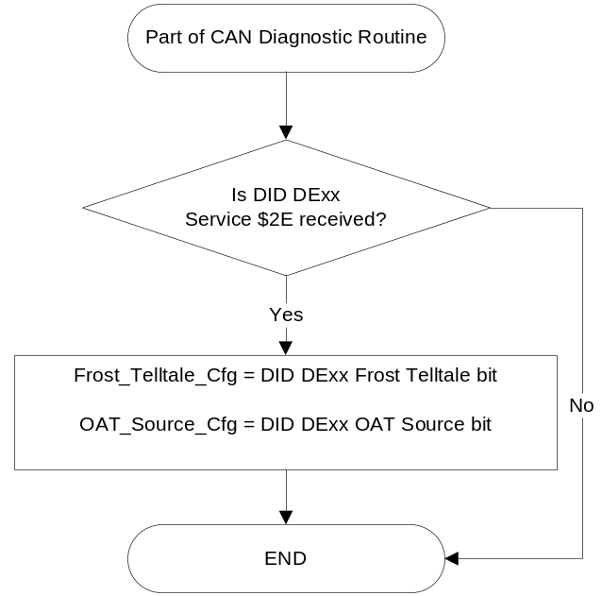

Figure 3 Frost Indication Telltale Routine
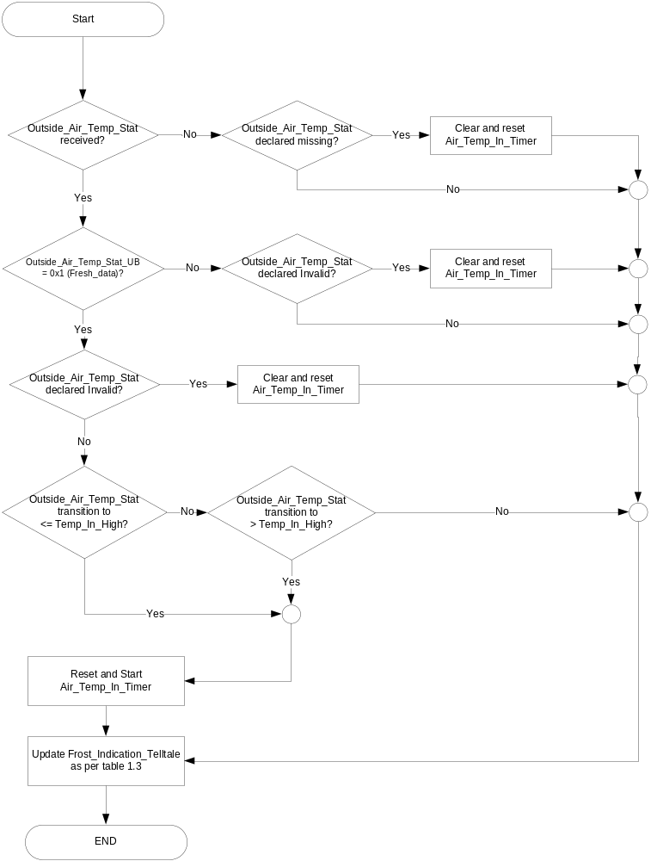

- State Matrix for Frost Telltale
Operational_Mode | Frost_  Telltale_Cfg | ETM Bulb_ Check_State | DIAG_SESSION_TIMER | Self_Test_ Entry_Bulb_ Check_Timer | DIAG_DID_  61C6, Byte 5  (Frost Warning) | DIAG_DID_  61A5,4,6  (all warning  lamps) | Bulb_  Proveout_  Timer | Outside_Air_  Temp_Stat Signal | Air_Temp_In_Timer | Frost_ Indication_ Telltale | FrostWarn_D_  Stat Signal
Normal or Crank | Enabled | X | Not Active | X | X | X | Active | X | X | ON_Amber | No State Change
Normal or Crank | Enabled | X | Not Active | X | X | X | X | <= Temp_In_High | Not Expired | No State Change | No State Change
Normal or Crank | Enabled | X | Not Active | X | X | X | X | <= Temp_In_High | Expired | ON_Amber | On_Amber (0x2)
Normal or Crank | Enabled | X | Not Active | X | X | X | X | > Temp_In_High | Not Expired | No State Change | No State Change
Normal or Crank | Enabled | X | Not Active | X | X | X | X | > Temp_In_High | Expired | OFF_Amber | Off (0x0)
Normal or Crank | Enabled | X | Not Active | X | X | X | X | Declared missing or invalid as per 1.4.1 | X | ON_ Amber | On_Amber (0x2)
Normal or Crank | Enabled | ON (0x1) | Not Active | X | X | X | X | X | X | ON_Amber | On_Amber (0x2)
Normal | Enabled | X | Active | Not Active | Not Received | Not Received | Active | X | X | ON_Amber | No State Change
Normal | Enabled | X | Active | Not Active | Not Received | Not Received | X | <= Temp_In_High | Not Expired | No State Change | No State Change
Normal | Enabled | X | Active | Not Active | Not Received | Not Received | X | <= Temp_In_High | Expired | ON_Amber | On_Amber (0x2)
Normal | Enabled | X | Active | Not Active | Not Received | Not Received | X | > Temp_In_High | Not Expired | No State Change | No State Change
Normal | Enabled | X | Active | Not Active | Not Received | Not Received | X | > Temp_In_High | Expired | OFF_Amber | Off (0x0)
Normal | Enabled | X | Active | Not Active | Not Received | Not Received | X | Declared missing or invalid as per 1.4.1 | X | ON_ Amber | On_Amber (0x2)
Normal | Enabled | ON (0x1) | Active | Not Active | Not Received | Not Received | X | X | X | ON_Amber | On_Amber (0x2)
Normal | Enabled | X | Active | X | 0x02 | X | X | X | X | ON_Amber | On_Amber (0x2)
Normal | Enabled | X | Active | X | X | ON (0x1) | X | X | X | ON_Amber | On_Amber (0x2)
Normal | Enabled | X | Active | Active | X | X | X | X | X | ON_Amber | On_Amber (0x2)
All Other Cases |  |  |  |  |  |  |  |  |  | OFF | Off (0x0)
X= Don’t Care
Not Received = The state when a DIAG_SESSION_TIMER is active and the DID has not been received.

- State Matrix for Temp_In_High
Display_Units_Te_MC | Temp_In_High | Outside_Air_Temp_Stat
English (0x0) | 39°F | 0x58
Metric (0x1) | 4.5 °C | 0x59

Operation Description (supports algorithm flowchart /state diagram)

Function Safety Classification (EMC)

Class B

Memory Storage

Parameter Name | Description | Value at  Battery Connect | Value at  Module Wake-up
Frost_Indication_Telltale | Used to control the state of the LED | OFF (0x0) | OFF (0x0)
Outside_Air_Temp_Stat Signal | CAN signal sent from the BCM for Outside Air Temp | -40 (0x0) | -40 (0x0)
Outside_Air_Temp_Stat_UB Signal | CAN signal sent from the BCM used to identify the update bit of the Outside_Air_Temp_Stat signal. | 1 (0x1) | 1 (0x1)
FrostWarn_D_Stat Signal | Output CAN signal sent by the cluster.  (Note: This signal’s state is Off during Bulb Proveout.) | OFF (0x0) | OFF (0x0)
Temp_In_High | The upward trip point for Frost Indication Telltale in units of CAN message. This is defined as 4°C when temperature display is in Celsius, and 39°F when temperature display is in Fahrenheit. Parameter is calculated based on Display_Units_Te_MC | 4.5 °C | Use Stored Value
Display_Units_Te_MC | Output that controls display indicating Temperature units to the driver (i.e. when English: Fahrenheit; when Metric: Celsius). (See Display Unit Selection Control Function - CGEA1.3 STSS) | (See Display Unit Selection Control Function - CGEA1.3 STSS) | (See Display Unit Selection Control Function - CGEA1.3 STSS)
DIAG_DID_61C6,Byte 5 (Frost Warning) | Warning Lamp Status 1, Byte 2, Bit 3 (Frost Lamp Amber) | OFF (0x00) | OFF (0x00)
DIAG_DID_61A5,4,6 (all warning lamps) | Warning Lamp status 2, byte 4, bit 6 (all warning lamps) | 0 (0x0) | 0 (0x0)
ETM_Bulb_Check_State | State indicator for warning bulb in ETM | OFF (0x0) | OFF (0x0)
Frost_Telltale_Cfg | Indicator of feature presence controlled via CAN at EOL at VO plant. | Use Stored Value | Use Stored Value
OAT_Source_Cfg | Indicator of feature presence controlled via CAN at EOL at VO plant. | Use Stored Value | Use Stored Value
Operational_Mode | 4 state indicator for cluster operational mode | Limited | Limited or Normal or Crank

Parameter Name | Description | Value at Battery Connect | Value at Module Wake-up
DIAG_SESSION_TIMER | Timer used to time-out a diagnostic session | Not Active | Not Active
Self_Test_Entry_Bulb_Check_Timer | Timer used in diagnostic session to do a self check of telltales | Not Active | Not Active

Parameter Name | Description | Range | Units | Resolution | Init Value
Air_Temp_In_Timer | Timer used to trigger telltale illumination based on temperature input. | 0-20 | seconds | 1/2 sec | 10 seconds

Prove Out

3.0 +/- 0.1 seconds as per bulb prove out section. Cluster controls prove out as per table 1.3 in section 1.3.5.1. No DTCs shall be logged while in Prove Out.

Reconfigurable Telltale

No

Message Center Msg

None

Error Handling

Missing Message Strategy

The current CAN messaging strategy does not log “missing” DTC for this feature, only “Invalid” DTC’s since message uses Update Bits.

Invalid Message Strategy

The signals will be declared invalid as per the Diagnostics section of this SPSS.

DTCs states and history will be determined as per the Diagnostics section of this SPSS.

Diagnostics

Self Test

Bulb illuminated during self test as per Self_Entry_Bulb_Check_Timer.

Engineering Test Mode

Reference section “Dealer / Engineering Test Mode (ETM)”

Part II Perfomance

Supported Diagnostic DIDs (Service $22 and $2F)
Number | DID / CommonID Name | DID Type
61C6, Byte 5 | Warning Lamp Status, Byte 5 (Frost Warning)  0x00 = OFF  0x01 = RED (NOT USED)  0x02 = AMBER  0x03 = OFF | State Encoded
61A5, 4, 6 | Warning Lamp Status 2, byte 4, bit 6 (all warning lamps) | Bit Mapped

Supported Diagnostic Trouble Codes (DTCs)

DTCs shall be logged as per the diagnostic section of this SPSS.
If vehicle equipped with stand alone HVAC thus OAT_Source_Cfg = 0 (HVAC):
DTC | Description
C42482* | Invalid Data Received from HVAC Control Module – Alive / Sequence Counter Incorrect / Not Updated
C42481 | Invalid Data Received from HVAC Control Module – Invalid Serial Data Received
C42400 | Invalid Data Received from HVAC Control Module
*C42482 applies only when the missed signal has an associated _UB signal. Currently, CGEA 1.3 vehicles use Outside_Air_Temp_Stat_UB, and CGEA 1.3LC (Low Content) vehicles do not.

If vehicle equipped with HVAC integrated into FCIM thus OAT_Source_Cfg = 1 (FCIM):
DTC | Description
C55782* | Invalid Data Received from FCIM Control Module – Alive / Sequence Counter Incorrect / Not Updated
C55781 | Invalid Data Received from FCIM Control Module – Invalid Serial Data Received
C55700 | Invalid Data Received from FCIM Control Module
*C57782 applies only when the missed signal has an associated _UB signal. Currently, CGEA 1.3 vehicles use Outside_Air_Temp_Stat_UB, and CGEA 1.3LC (Low Content) vehicles do not.

DID DExx
Size (bits) | State: Description | "0" | "1" | Default | Comments/  Information
1 | Frost Telltale | Disabled | Enabled | Disabled | Enable ONLY for FoE and Russia.  Disabled for NA and APA and all other markets.
1 | OAT Source | HVAC | FCIM | FCIM | 0 if vehicle has a stand-alone HVAC unit  1 if vehicle has an integrated HVAC in the FCIM
Note: Byte and bit location to be identified in Part II Specification for this cluster

Reference Specification

IS-0001 WARNINGS/INDICATORS/DISPLAYS PROVEOUT
IS-0052 OPERATING VOLTAGES - FUNCTIONAL/PERFORMANCE
IS-0069 FUNCTIONAL IMPORTANCE CLASS
IS-0324 WINDSHIELD & OTHER REFLECTIONS
IS-0327 WARNING INDICATOR EVALUATION
IS-0329 FLICKERING OF LAMPS
IS-0379 NORTH AMERICAN WARNINGS AND INDICATORS STRATEGY

IL-0017 TELLTALE AND INTERIOR ILLUMINATION COLOR
IL-0021 CRAFTSMANSHIP - DISPLAYS
IL-0023 CLARITY/LEGIBILITY/READABILITY
IL-0025 INTERIOR ILLUMINATION INTENSITY
IL -0027 VISUAL CONTRAST
IL -0043 OPERATIONAL ENVIRONMENT FUNCTIONALITY
IL -0045 COLOR
IL -0047 TELLTALE; INDICATOR AND DISPLAY LIGHT INTENSITY
IL -0048 ILLUMINATION ACCEPTABILITY

03-0661 PLACEMENT: CONTROL AND DISPLAY LOCATIONS
03-0662 PLACEMENT: LOGICAL GROUPING FUNCTION AND USAGE
03-0664 PLACEMENT: DOWN VISION TO COMPONENTS WITH HIGH VISUAL DEMAND
03-0665 PLACEMENT: EXPECTED LOCATIONS OF CONTROLS AND DISPLAYS VDS
03-0670 INTERIOR VISIBILITY
03-0671 INTERIOR VISIBILITY: REFLECTIONS FROM COMPONENTS & SURFACES
03-0672 INTERIOR VISIBILITY: REFLECTIONS IN DISPLAYS
03-0673 INTERIOR VISIBILITY: VISUAL OBSCURATIONS
03-0674 INTERIOR VISIBILITY: ILLUMINATION CONTROLS / DISPLAYS
03-0675 INTERIOR VISIBILITY: VEILING GLARE
03-0677 INTERIOR VISIBILITY: SUNLIGHT WASHOUT
03-0681 IDENTIFICATION: CHARACTER AND SYMBOL SIZE
03-0682 IDENTIFICATION: LEGIBILITY
03-0685 IDENTIFICATION: SYMBOLS, ABBREV FOR CONTROL
03-0721 LOGIC OF OPERATION: OPERATIONAL STEREOTYPES
03-0722 LOGIC OF OPERATION: INTERPRETATION
03-0723 LOGIC OF OPERATION: USE OF SYSTEMS WITH VISUAL DISPLAYS

Revision History

SPSS Module Revision History

Revision Level | Name | Change Description | Date
1.0 | V.Patel | Initial Release based on C346 CTS. | 7/23/2010
1.1 | V.Patel | Section 1.3.5.1: Updated table 1.3 to transmit appropriate telltale status output signal even during prove-out, ETM, diag and Self Test modes. | 7/30/2010
2.0 | S. Watkins | Updated for clarity.  - Section 1.3.5.1 – Changed wording in bottom middle decision diamond for clarity.  - Table 1.3 – Added 6 rows to for cases of “Air_Temp_In_Timer” of “Not Expired” with an action of “No State Change”. | 6/24/2011
3.0 | S. Watkins | Decision was made to remove Red color per warranty concerns in Europe and China. The Red state has agreed to be removed ( violated IH006, and is even claimed by EU customers in GQRS Q1).  It was decided to use a configuration per market – EU/Russia only. Also went through DI Change Control:  Minutes from DI Change Control for 6/28/2012:  - Global strategy frost TT (Wolfgang Krug)  - PCA approved for FoE to investigate in DI Forum. PCA for FAPA and FNA is to configure this telltale off or do not provide in cluster.  - Team to determine whether this telltale is really necessary for all clusters to have due to cost of fixed telltale.  Changes:  - Section 1.1 – Updated description to remove Red color  - Section 1.3.5.1 – Modified decision diamond to remove check on Temp_In_Low. Re-wrote Table 1.3, removing Red color and Temp_in_low.  - Section 1.4.1 – Added note that “missing” does not apply.  - Section 1.5.3 – Changed DTC’s from HVAC to FCIM. Also changed DE00 comments to include Russia. | 7/16/2012
4.0 | T. Cwik | Update to correctly identify the ECU against which to log a DTC.  Section 1.1 – Added “the HVAC or”  Section 1.2.1 – Figure 1 - Added OAT Source  Section 1.3.5.1 –  – Added Figure 2  – Added title for Figure 3 and added Decision Diamond of “Outside_Air_Temp_Stat declared Invalid?” and associated paths  Section 1.3.5.4 – Added Frost_Telltale_Cfg and OAT_Source_Cgf  Section 1.5.3 – Rewrote the DTC section and added OAT Source to the DExx Table | 9/16/2014
5.0 | T. Cwik | Update to correct performance for Bulb Proveout.  Section 1.1 – Added “The Fixed Telltale is illuminated …”  Section 1.3.5.1 – Table 3.0 – Added two rows with “Bulb_Proveout_Timer = Active” and one row with “ETM Bulb_ Check_State = On”.  Section 1.3.5.4 – Added Note to Description for FrostWarn_D_Stat | 1/12/2015
6.0 | S. Watkins | The FoE team noticed that when the OAT is 4.5C, the OAT display is 4C (whether displayed in cluster or centerstack), but the Frost RTT/telltale is not active. So this is inconsistent with Owner Guide which states the Frost warning is active at 4C/39F. The solution to account for this half degree issue is to change the trigger point based on whether units are Celsius or Fahrenheit.  This means that Temp_In_High is now a variable (instead of a constant).  The Frost warning will trip at 4.5C (40F) when units are in Celsius, and will trip at 4C(39F) when units are Fahrenheit.  - Section 1.1 – Added “or 39F”  - Section 1.2.1 – Added Display_Units_Te_MC  - Section 1.2.2 – Added Display_Units_Te_MC  - Section 1.3.5.1 – Added Table 1.4 for Temp_In_High  - Section 1.3.5.4 – Changed Temp_In_High from a constant to a variable, and added Display_Units_Te_MC | 4/8/2016

